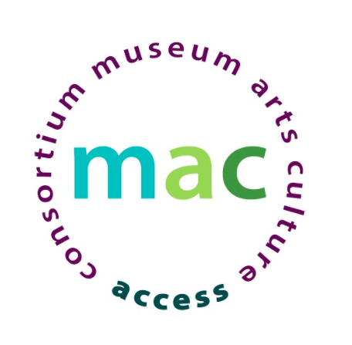

Experiences in Audio Description for the Visual and Performing Arts

A Virtual MAC Workshop: Resource List

Panelist Information

Ruth Starr, Accessibility Manager, Cooper Hewitt, Smithsonian Design Museum
Starrr@si.edu

Nefertiti Matos, Access Technology Educator, New York Public Library, Andrew Heiskell Braille and Talking Book Library
NefertitiMatos@nypl.org and www.linkedin.com/in/nefertiti-matos

Kyle Wright, Shubert Ticketing, Digital Projects Director
kylew@shubertticketing.com
Peter Trojic, Accessibility + Technology Director I Dancer, Heidi Latsky Dance
peter@heidilatskydance.org

Audio Description Examples
Expedition, from Willi Smith: Street Couture
A Grain of Sand, from Nature— Cooper Hewitt Design Triennial
The Jewish Museum
Museum of Modern Art

Audio Description Guidelines
Art Beyond Sight
AD Resource Guide - National Library Service for the Blind and Print Disabled (NLS)

Audio Description Tools
Prime Access Consulting
JJ Hunt at Prime Access
Galapro
iCaption
The Audio Description Project
Apple Accessibility is for everyone!

